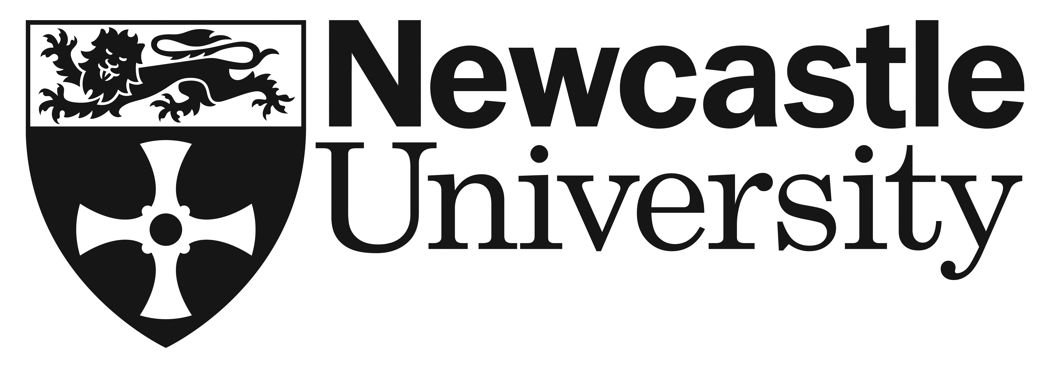 | Council Tax EXEMPTION Request
To be completed by PGR students who are ‘Under Examination’ (and registered on a full-time research programme prior to submission) who wish to request a Council Tax Exemption certificate.
- ‘Under Examination’ PGR students are not automatically eligible for a Council Tax Exemption certificate and the University is required to confirm that a student is continuing to attend University on a full-time basis, in accordance with the regulations set by the Local Authority for Council Tax exemption.
- Please note that staff candidates and students who are working full-time while ‘under examination would not be eligible for a council tax exemption certificate.

SECTION B - STUDENT DETAILS:
Name of Student:  Student Number: | University email address:  @ncl.ac.uk  (The outcome of your request will be communicated to you via this email address)
Name of Supervisor(s): | School / Institute:
Programme: | Thesis Submission Date:

DETAILS OF CURRENT ACTIVITY
Outline the study you are undertaking while ‘Under Examination’ and how this fulfils the Local Authority’s requirements for Council Tax exemption:
- undertaking study of at least 21 hours per week and
- attending for at least 24 weeks within an academic year

DATES COUNCIL TAX EXEMPTION IS REQUESTED FOR:
From: |  | To:

STUDENT DECLARATION
By submitting this request, I declare that the information submitted above is accurate.
Signature: | Date:

STUDENTS IN THE FACULTIES OF HASS AND SAGE SHOULD NOW RETURN THIS REQUEST TO: gradschool@ncl.ac.uk
STUDENTS IN THE FACULTY OF MEDICAL SCIENCES SHOULD NOW RETURN THIS REQUEST TO:
medpg-enquiries@ncl.ac.uk

On receipt of this request, the University will consider your eligibility for an exemption certificate and advise you of the decision by email. On receipt of a request, the University will consider your eligibility for an exemption certificate, in liaison with your Supervisory Team. The University will advise you of the decision by email.

